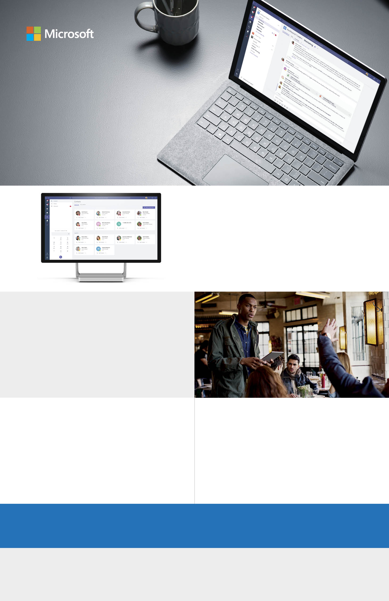

One place for conversations, meetings, and calls

Chat privately one-on-one or have instant group conversations. Join meetings with HD audio and video, all in one place, instead of multiple apps.

**Add your message here.** Lorem ipsum dolor sit amet, consectetur adipiscing elit. Donec mattis enim eu lorem malesuada hendrerit. Suspendisse eget quam et ipsum pretium ultrices. (200 character max)

## Go to [**www.aka.ms/MicrosoftTeams**](http://www.aka.ms/MicrosoftTeams)For additional guidance, tutorials and tips visit [**www.successwithteams.com**](http://www.successwithteams.com)

## Start using Teams

Tailor your workspace

Get notifications and content from services you care about—Trello, GitHub, Adobe Creative Cloud, SurveyMonkey, and many more.

Security and compliance

Teams is integrated into Office 365, which means it features the enterprise-grade security and compliance you need.

Collaborate with integrated Office 365 apps

Office apps and services that you use every day—Word, Excel, PowerPoint, OneNote, SharePoint, Stream, and Power BI—are built-in, giving you access to files and tools in one place, so you stay in your workflow.

## Your new hub for team files, conversations, and meetings. All in one place, wherever you go.

# Introducing Microsoft Teams